OPEN FOR BUSINESS | - KEEPING YOU  - •  - SAFE
  Our Priority is Keeping the Community Safe. Your health & safety means everything.  We are committed to  - Maintaining physical distancing where possible  - Increased hand hygiene measures to help stop the spread.  - Regular wiping down and disinfecting of surfaces and equipment.  - Encouraging staff and patients to stay at home if they are unwell.  Audiology is considered an Essential health service so we shall remain open.  Extra home visits and Telehealth appointments can be arranged. Please contact us for more information | 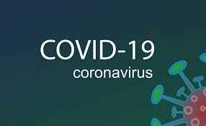  Sound Advice  Hearing Consultants  8376 6436  Mill Park, Whittlesea & Templestowe  Audiology is considered an Essential health service so we shall remain open.  Extra home visits and Telehealth appointments can be arranged. Please contact us for more information

